Project Design Phase-II

Data Flow Diagram & User Stories

|  |  |
| --- | --- |
| Date | 03 October 2022 |
| Team ID | PN2022TMD41919 |
| Project Name | SmartFarmer-IoT Enabled smart  Farming Application. |
| Maximum Marks | 4 Marks |

Smart Farming Application Flow Diagram:

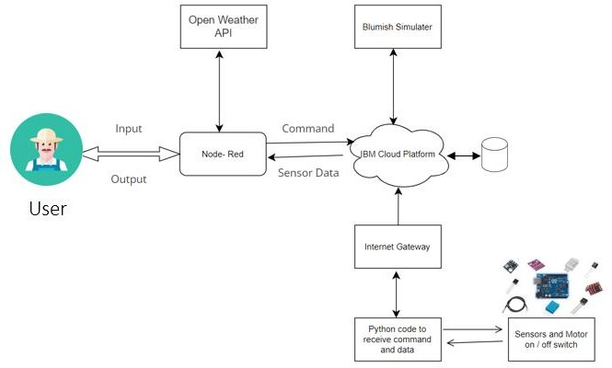

Data Flow Diagrams:

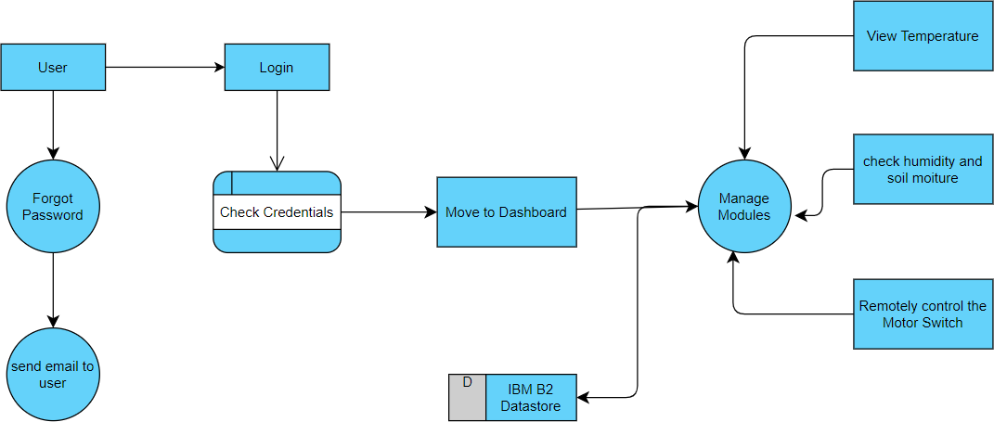

User Stories

|  |  |  |  |  |  |  |
| --- | --- | --- | --- | --- | --- | --- |
| **User Type** | **Functional Requirement (Epic)** | **User Story Number** | **User Story / Task** | **Acceptance criteria** | **Priority** | **Release** |
| Customer (Mobile user) | Registration | USN-1 | As a user, I can register for the application by  entering my email, password, and confirming my password. | I can access my account in dashboard | High | Sprint-1 |
|  |  | USN-2 | As a user, I will receive confirmation email once I have registered for the application | I can receive confirmation email and click confirm | High | Sprint-1 |
|  |  | USN-3 | As a user, I can register for the application through Gmail | I can easily register the application | Medium | Sprint-1 |
|  | Login | USN-4 | As a user, I can login to the application by entering email and password | I can login through Gmail | High | Sprint-1 |
| Customer (Web user) | Dashboard | USN-2 | As a User can view the dashboard, and this dashboard include the check roles of access  and then move to the manage modules. | I can view the dashboard in this smart farming  application system. | High | Sprint 2 |
|  |  | USN-1 | User can remotely access the motor switch. | In the smart farming app | High | Sprint 3 |
|  |  | USN-3 | As a user once view the manage modules this  describes the Manage system Admins and Manage Roles of User and etc. | I can register and access the information through Gmail login | Medium | Sprint 2 |